**CSc 102 Project Documentation**

Group members:

Jonah Bischof (g19B6388)

Muhluri Mhlongo (g19M5813)

Ayabonga huwa (g19H8159)

Title of Project (Game): **Shithead**

**Proposal Documentation**

Background and Motivation:

Shithead is a card game that is played with a full deck of cards, without jokers. With a regular deck, between two and six players play against each other (any of the players can be the computer). Each player is dealt three cards face down, three face up on top of the face down cards and three in the hand (the face down cards may not be seen by the players) (Lanyado, 2008).The left over cards are placed in a replenish pile. The person with a three in their hand (or if no one has a three, the person with the lowest card above three) starts by placing that card face up on the table, creating a discard pile (Sherret, 2018). Play continues clockwise, with each player placing a card that is equal to or bigger than the card at the top of the discard pile (unless the card is a seven). As each player plays a card they replenish their hand from the replenish pile. If all four cards of a number are played the discard pile is cleared, the cards are placed to the side, and the last person to play a card starts the pile again with any card they’d like to (Lanyado, 2008). If a player can’t place a card they have to pick up the discard pile and add it to their hand, the next player then restarts the pile with any card they want. Once the replenish pile is finished the players continue till their hands are finished. When a players hand is empty they play any of their face up cards and once those are done the face down cards. If the players are not able to play any of their face up or face down cards they pick up the discard pile and place the face down or face up card back. The first person to get rid of all their cards is the winner and the last person with cards is the **Shithead**.

There are special cards that have specific abilities, these cards change depending on the variation. In this variation the special cards will be: 2; can be placed at any time, 10; can be placed at any time and clears the discard pile, 7; the card played directly after it has to be lower than it (McLeod, 2012), 4; skips the next players turn.

**Problem Statement:**

The aim of this version of Shithead is to determine who the shithead is by seeing who has cards left by the end (Sherret, 2018). A player loses his cards by playing a number higher than or equal to the number on the discard pile. The base game has a medium complexity but extra features will be added to attempt to increase the complexity, attractiveness and depth for use of the game globally.

**Approach:**

Our project aims to create a card game in java by achieving the following milestones: Code a data structure (an array) that resembles a deck of 52 cards without jokers. Up to six players can play this game at a time including computer players. Therefore the program will have to keep track of the player’s cards with additional data structures. A GUI will be implemented to improve the games attractiveness and user friendliness. This work will finally be presented for assessment in the form of GitHub code and this project document. The extension to this proposal includes a walkthrough of the steps taken in the SDLC that was adopted by our group, and a Visual Demo of the game.

|  |  |
| --- | --- |
| Timeline | |
| Data structure for deck | 7 September 2019 |
| Shuffle function | 14 September 2019 |
| Base game and Player class | 20 September 2019 |
| Include special cards in base game | 5 October2019 |
| GUI | 9 October 2019 |
| Document | 11 October 2019 |

# References

Lanyado, B. (2008, November 22). *Shithead*. Retrieved from The Guardian: https://www.theguardian.com/lifeandstyle/2008/nov/22/rules-card-games-shithead

McLeod, J. (2012, July 8). *Shithead*. Retrieved from pagat: https://www.pagat.com/beating/shithead.html#variations

Sherret, M. (2018, December 3). *How to Play the Card Game Called Bastard (Also Known as Shithead, Shed, Palace or Karma)*. Retrieved from Hobby Lark: https://hobbylark.com/card-games/How-to-play-Bastard-the-card-game

**Software Development Life Cycle (SDLC):**

* Requirements and Analysis:

On 03 September we meet to discuss the game we could code as a group. After careful consideration we decided to go for Shithead (not only because of the name of the game) but also because of its uniqueness.

Luckily we can all access the Hamilton labs to use the computers as a resource. Plus they have access to the internet which caters for any information we would like to look up. We also used the textbook provided by the course as a baseline resource. The textbook and internet became a huge supply of information when working on the project.

On the 4th we discussed and concluded that this game can be played by oneone literate enough to use a computer. So there is no age restriction for the game (excluding the explicit name of the game)

We then met up on the 7th of September and discussed how the various program components be used. We spoke of how we will need 3 classes which are player, shuffle and shithead(the game). The player class will handle the player’s options and moves to make during the game. The shuffle will handle the shuffling of cards. And the shithead (the main program) will combine the other classes to make the full program of the game. This includes the menu of the game, the shuffles done and the number of players playing in the game. To ensure that the game works smoothly, we should ensure that all these three classes work accordingly.

* Design and Implementation :

The risks we faced included the coding of the shithead class to work accordingly, ensuring that the GUI works properly, and choosing a game with many special cards. Meaning the coding required would be very demanding.

Our data structures are mostly done with ones and zeros (coding). The visuals are only presented in ou GUI. The coding is done using java and java swing for our GUI. Below lies the visual representation of how the game operates from the command prompt (storyboards).

On 14 September we started working of the shuffles we used in the game. These shuffles are Riffle shuffle and the Fisher shuffle. It took a while to get them done but with the assistance which we received from class we managed to get it done. On 20 September we then stared working on the other two classes (shithead and player). The player class was managable but the shithead got us working until the final night. The GUI was started on the 9th of October and it also took a while to finish. No financial budget was required, however, we had to budget our time wisely in order to ensure that the game works properly.

The Waterfall model was used for the SDLC framework. This is because we knew all that we need before we began, milestones were understood and established, the classes made feed off each other, and since there was no cost required, we aimed for quality.

**Visual Guide:**

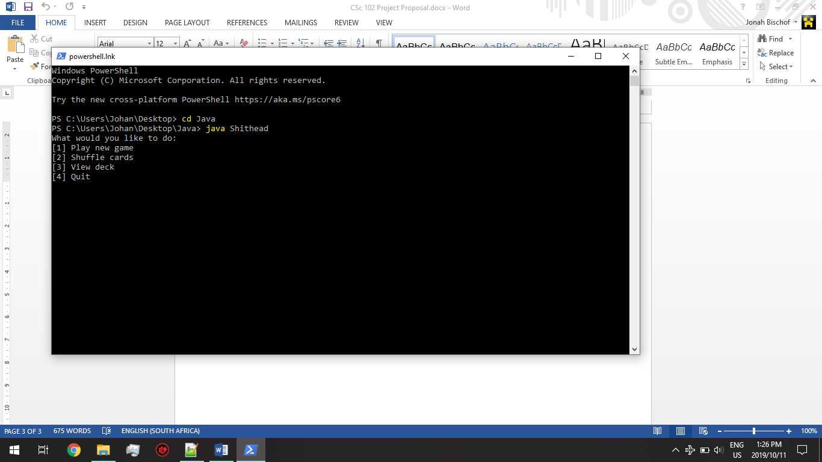

In this first picture we see the main menu of the game. It provides the user with the option to play, shuffle cards, view deck, or quit the game.

2)

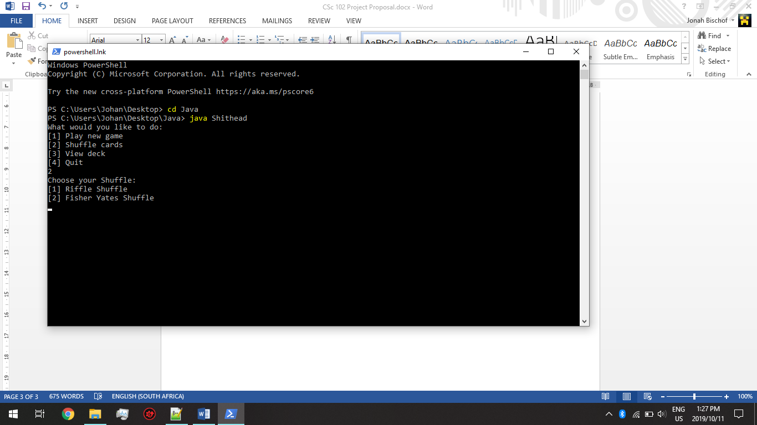

In this second image, we see how the user has selected the shuffle option. The program thus provides the two shuffle methodes mentioned above.

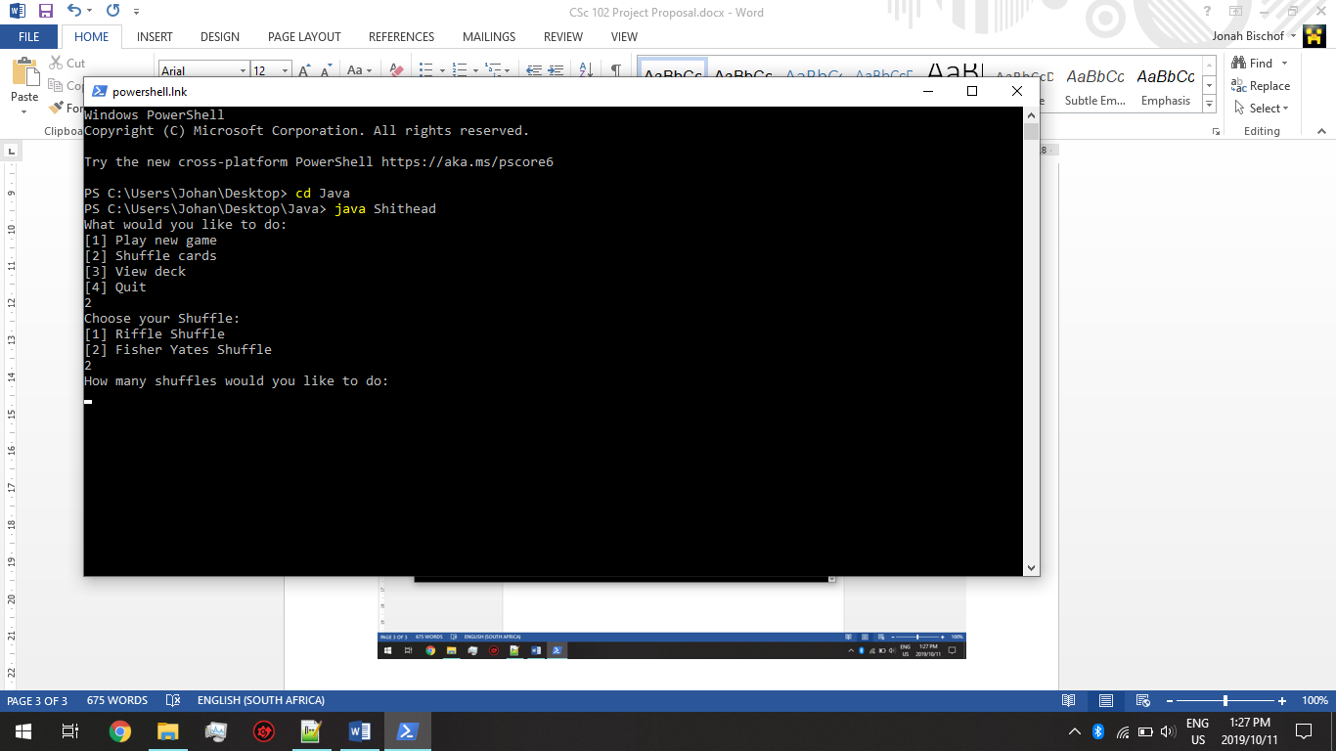

In this frame, the user is asked the number of shuffles he would like, using the method to shuffle chosen above.

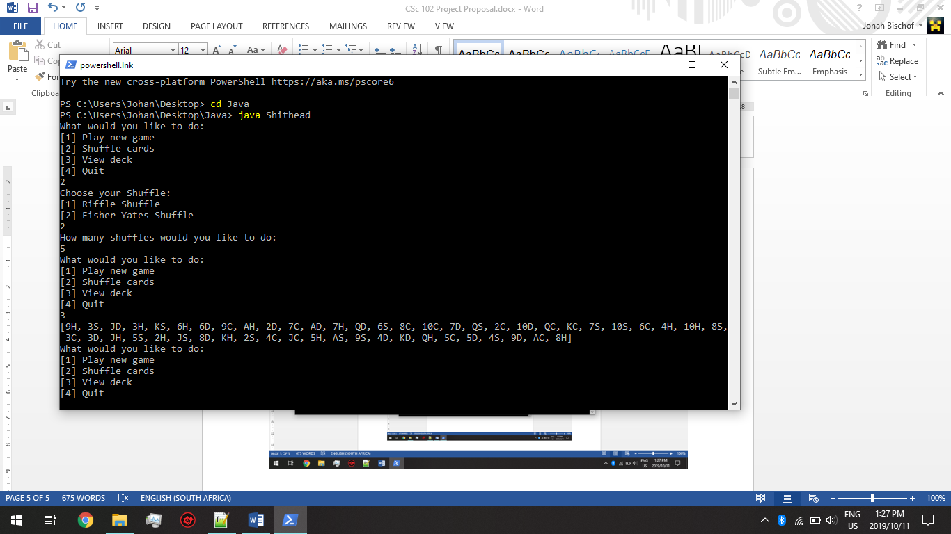

The program thus shuffles and returns to the main menu. The user then chose to view the deck then it was displayed.

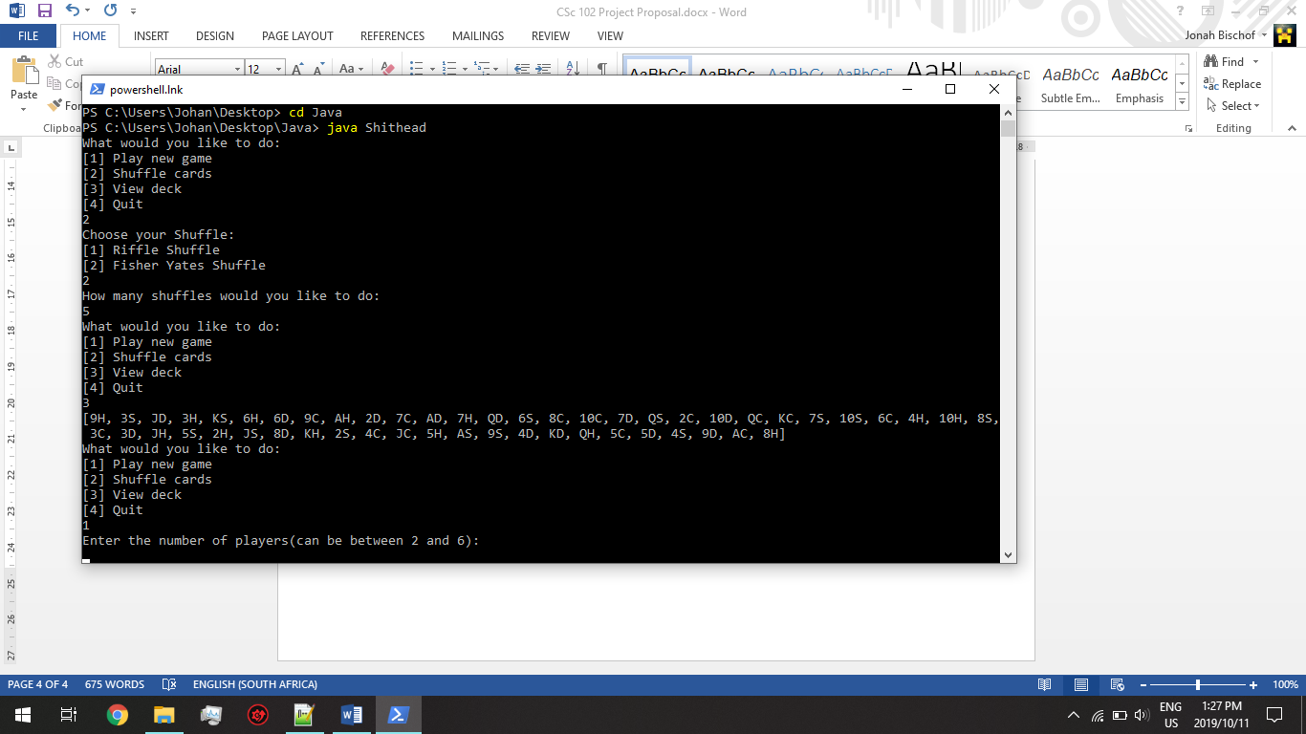

The user selects to play the game and thus the program requests the number of players.

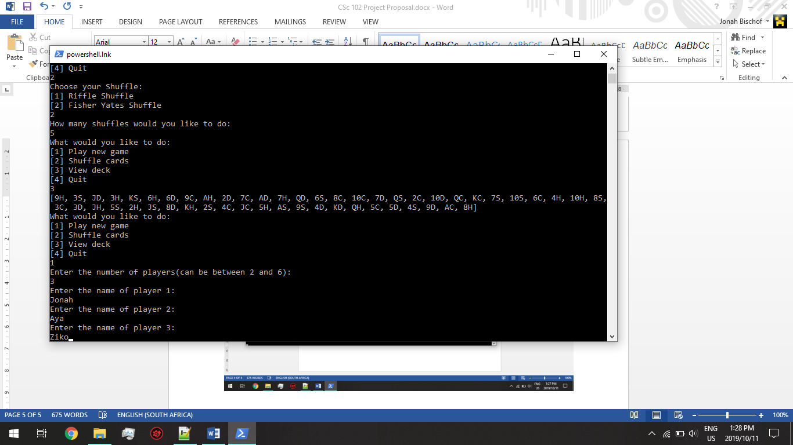

The number and names of players are entered then the program saves them.

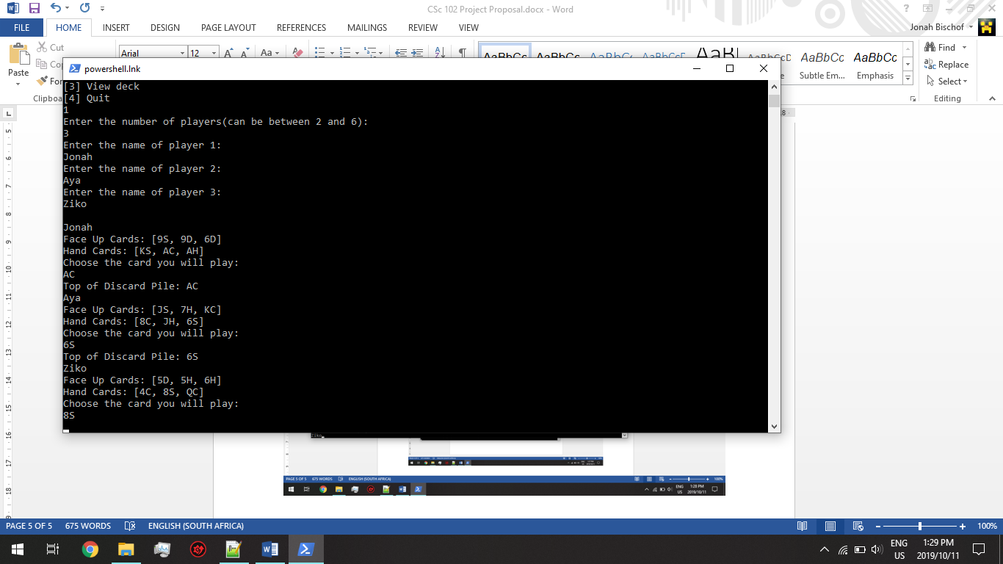

This illustrates how the game is played once names have been inserted.